17.90: In deriving Eq. (17.12), it was assumed that 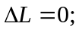 if this is not the case when there are both thermal and tensile stresses, Eq. (17.12) becomes
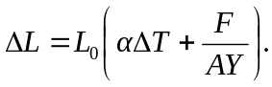
For the situation in this problem, there are two length changes which must sum to zero, and so Eq. (17.12) may be extended to two materials a and b in the form
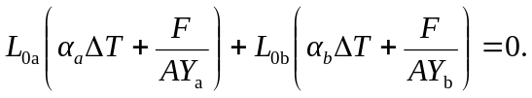
Note that in the above, 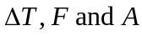 are the same for the two rods. Solving for the stress 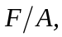
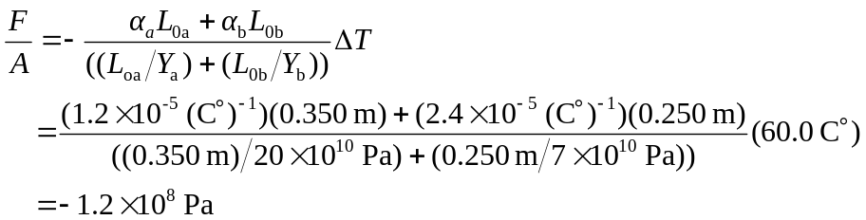
to two figures.

